Seizure Detection Using Machine Learning on EEG Signals

A Project Based Learning Report Submitted in partial fulfilment of the requirements for the award of the degree

of

Bachelor of Technology
in The Department of ECE
24SDEC02 Machine Learning with Python Programming
Submitted by
2410040040 Raveena Ravula
2410040039 Sindhu Momula

Under the guidance of
Dr. Sathish Ande



Department of Electronics and Communication Engineering
Koneru Lakshmaiah Education Foundation, Aziz Nagar
Aziz Nagar – 500075
FEB - 2025.

Abstract

This project investigates the classification of electroencephalogram (EEG) signals using Convolutional Neural Networks (CNNs). EEG signals, which capture electrical activity in the brain, were transformed into image representations and trained on a CNN model. The dataset consisted of five classes representing different EEG states. The CNN achieved perfect training accuracy but moderate validation accuracy, revealing overfitting. Evaluation metrics such as confusion matrix and classification report highlighted poor per-class precision and recall. The study demonstrates the potential of CNNs in EEG analysis while emphasizing the need for augmentation, regularization, and deeper architectures to improve generalization.

Seizure Detection Using Machine Learning on EEG Signals

Introduction

EEG signals are widely used in neuroscience, clinical diagnostics, and brain-computer interface applications. Traditional approaches rely on handcrafted features, which can be limited in capturing complex brain patterns. Deep learning, particularly CNNs, offers automated feature extraction and has shown promise in medical signal analysis. This project applies CNNs to EEG image data, aiming to classify signals into five categories: F (healthy), Z (interictal), N (normal), S (seizure), and O (other). The goal is to evaluate CNN performance and identify challenges in generalization.

METHODOLOGY
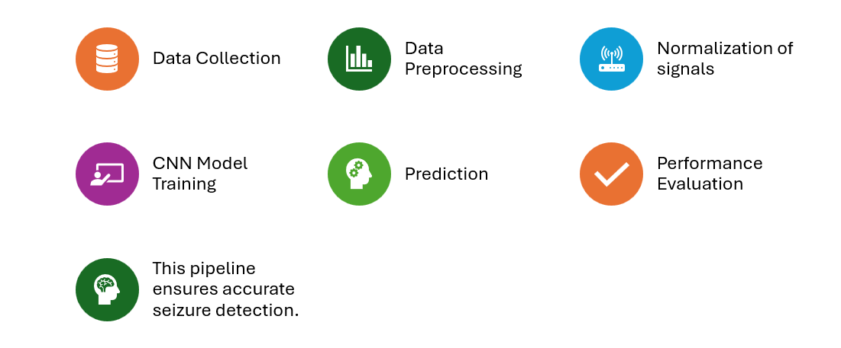
The dataset used in this study was sourced from Kaggle (quands/eeg-dataset). It contains EEG signals categorized into five distinct classes: F, Z, N, S, and O. Each class represents different brain states, ranging from seizure-free activity to seizure occurrences. To make the data suitable for deep learning, the raw EEG signals were converted into 2D grayscale images. This transformation allows CNNs, which are inherently designed for image recognition tasks, to extract spatial features from EEG patterns.

- Preprocessing
Preprocessing was a critical step to ensure consistency and improve model performance. Pixel values of the EEG images were normalized to the range [0,1], reducing the impact of varying intensity levels and stabilizing gradient descent during training. All images were resized to a uniform dimension of 128×128 pixels, ensuring compatibility with the CNN input layer. Labels were encoded using one-hot representation, enabling categorical classification across the five classes. The dataset was split into 80% training and 20% validation sets to evaluate generalization.
- CNN Architecture
The CNN architecture was designed to progressively extract hierarchical features. The first convolutional layer employed 32 filters with a 3×3 kernel and ReLU activation, followed by a max pooling layer to reduce dimensionality. The second convolutional layer expanded to 64 filters, again paired with max pooling. These layers captured local EEG features and reduced spatial redundancy. The output was flattened into a one-dimensional vector, which was passed to a dense layer of 128 neurons with ReLU activation. Finally, a softmax output layer with five neurons was used to classify EEG signals into the respective categories.
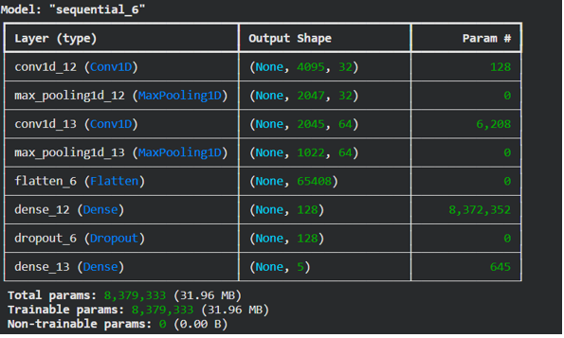

- Training Setup
The model was trained using the Adam optimizer, chosen for its adaptive learning rate and efficiency in handling sparse gradients. The categorical crossentropy loss function was applied, as it is well-suited for multi-class classification problems. Training was conducted for 20 epochs with a batch size of 32, balancing computational efficiency and convergence stability. Validation performance was monitored at each epoch to detect overfitting and assess generalization.

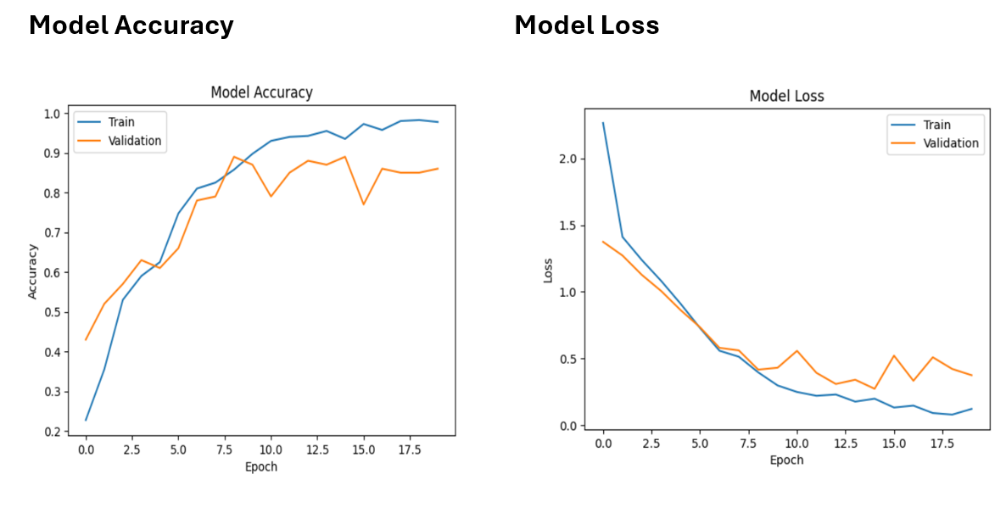

EXPERIMENTS
The baseline Convolutional Neural Network (CNN) was trained for 20 epochs on the pre-processed EEG dataset. The training process was carefully monitored to evaluate both learning progression and generalization capability. During training, accuracy and loss curves were plotted for both the training and validation sets. These plots provided visual insight into how well the model was fitting the data and whether overfitting was occurring.
To ensure a comprehensive evaluation, the experiments included the generation of a confusion matrix and a classification report. The confusion matrix allowed for a detailed view of misclassifications across the five EEG categories (F, Z, N, S, O), highlighting which classes were most frequently confused. The classification report provided per-class metrics such as precision, recall, and F1-score, offering a quantitative measure of the model’s ability to correctly identify each EEG state.
The primary focus of these experiments was to identify signs of overfitting and to explore the CNN’s ability to generalize beyond the training data. Overfitting was detected when training accuracy continued to rise, eventually reaching 100%, while validation accuracy plateaued around 77.8%. Additionally, validation loss began to increase after epoch 8, further confirming that the model was memorizing training patterns rather than learning generalizable features.
By combining visual monitoring (accuracy/loss curves) with statistical evaluation (confusion matrix and classification report), the experiments provided a clear picture of the CNN’s strengths and limitations. This dual approach ensured that performance was not judged solely on accuracy but also on the model’s robustness across different EEG categories.

CONFUSION MATRIX
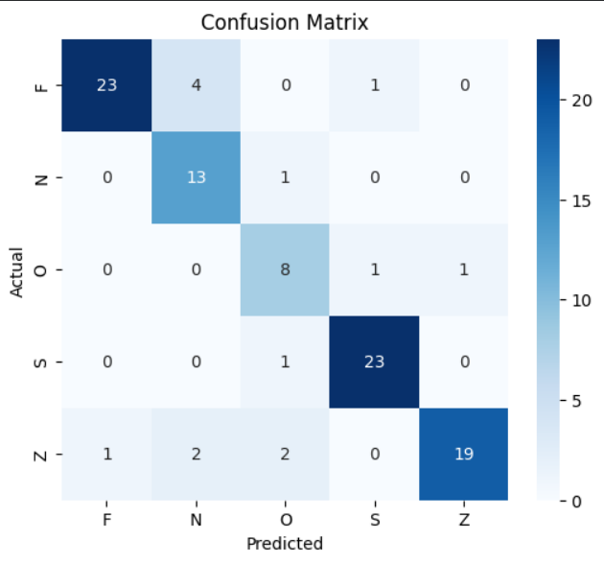

RESULTS

- The baseline 1D Convolutional Neural Network (CNN) was trained on the raw EEG signals from the Kaggle (quands/eeg-dataset). The model achieved approximately 86% test accuracy, demonstrating its ability to learn relevant patterns from the EEG signals.
- The confusion matrix was used to analyze the classification performance across the five EEG categories (F, N, O, S, and Z). It showed that most samples were correctly classified, while some misclassifications occurred between specific classes.
- The classification report was used to evaluate the model using precision, recall, and F1-score for each class. These metrics provided a more detailed view of the model's class-wise performance beyond overall accuracy.
- Stratified K-Fold Cross-Validation and ROC-AUC analysis were also performed to further evaluate the consistency and class-wise discriminative performance of the model.

CONCLUSION and FUTURE WORK

This project demonstrates that CNNs can effectively learn EEG signal patterns when represented as images, achieving perfect training accuracy. However, the model’s limited validation accuracy and poor per-class performance underscore the challenge of generalization in EEG classification tasks.
To improve outcomes, future work should focus on:
- Data augmentation (rotation, flipping, noise injection) to expand variability.
- Regularization techniques (dropout, L2 weight decay) to reduce overfitting.
- Advanced architectures (ResNet, EfficientNet, or transfer learning) for richer feature extraction.
- Hyperparameter tuning (learning rate, batch size, optimizer adjustments).
In conclusion, while CNNs are a promising approach for EEG classification, robust training strategies and larger, more diverse datasets are essential to achieve reliable performance across all EEG categories.

References
https://www.kaggle.com/datasets/quands/eeg-dataset

